New Si124 range improved bandwidth yields big savings for energy-intensive industries
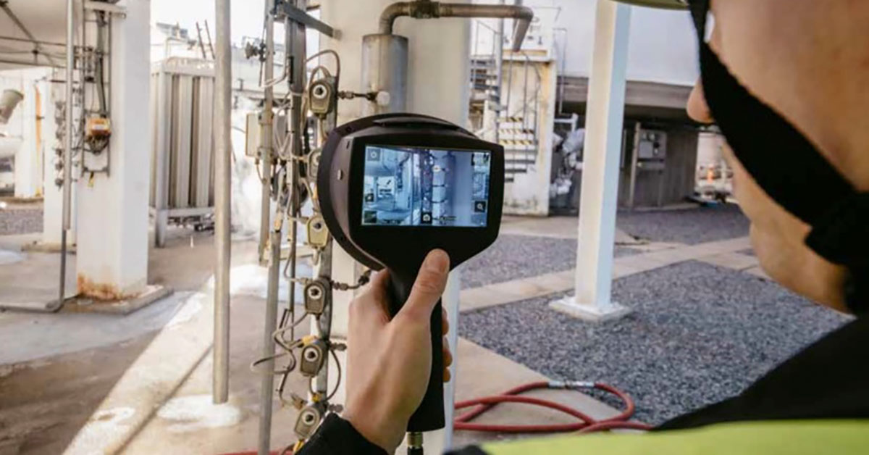

The Si124 range of acoustic cameras now detects air leaks from 2 - 65 kHz - and the small change means big operational improvements for industrial applications across sectors.

The Teledyne FLIR range of acoustic imaging cameras, the Si124, Si124-PD and Si124-LD, now offers an improved bandwidth range for detecting compressed air leaks in industrial settings. The change means that the industry-leading range can now detect leaks from anywhere between 2 to 65 kHz and adds crucial functionality to the previous peak bandwidth of 35 kHz.
While it may seem like a minor change, the operational impact of the improvements cannot be overstated: it means marked savings for industrial applications globally, reducing costs and improving reliability.

The improved Si124 range promises easier, more impactful inspections

The range of three cutting-edge Si124 models are now equipped to measure virtually all compressed air leaks in manufacturing settings - regardless of how small and seemingly insignificant. This unique range covering 63 kHz is scientifically the optimal sound spectrum range for detecting leaks, which occur on this measurable threshold. Detecting ranges outside of this spectrum actually detracts from long-term functionality as detecting background noise beyond 65 kHz can interfere with baseline readings and negatively impact leak detection.
Failure to detect air leaks can cost companies thousands of pounds in replacement costs for units that are not operating optimally, and can have a knock-on effect on production when parts are replaced and production lines forced into downtime.

Federico De Lucia, Team Lead of Condition Monitoring Specialists (EMEA Solutions) at Teledyne FLIR explains why this seemingly small change cements the Si124 range as operating across the optimum bandwidth for detecting compressed air leaks in industrial applications.

“Let’s look at, for example, a compressed air leak from a small hole of just 1.5 millimetres and on a network of compressed air at seven bars of pressure. Two years ago, with a price of €0.07 per kilowatt hour, that would have cost a company roughly €1500 (£1300) per year, if we assume an average operating time of 6000 hours.

“Now that the energy situation is more challenging, it means that costs may be three, four, even five times higher in some cases, which could be a cost of up to £7500 a year - which is a shocking amount simply for failing to identify a single small hole in a vital production component. This is staggering when you consider the scale of industrial manufacturing and the scope for leaks to crop up unnoticed.”

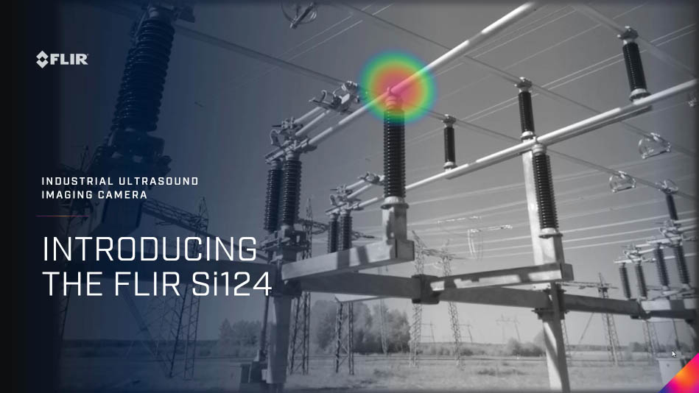
Tightness testing is an outdated model
“The EV industry is a particularly timely example of how acoustic imaging can be used to replace outdated inspection models, given the rising cost of energy on all fronts.
“This is because the batteries for electric vehicles must be hermetically sealed to ensure they hit operational guidelines and safety standards. They must be both airtight and watertight to keep dirt, dust and other external contaminants from penetrating the core components, which could cause the device to short-circuit and become a fire risk.
“Traditionally, these units were probed by mass spectrometers to identify foreign compounds within the casing or through the more rudimentary method of immersing the units in water to identify leaks by looking for air bubbles - which we call tightness testing - but this was incredibly impractical, as well as wasteful.
“Teledyne FLIR’s improved range of acoustic imaging can detect leaks quicker than this outdated model as well as identify much smaller leaks that are not visible to the naked eye, able to be heard by the ear, or even detected on traditional thermography. The improved bandwidth range of the Si124 ensures that operators are only focusing on the exact and specific frequencies that compressed air leaks can be detected on - and not wasting valuable battery power or AI functionality struggling to filter out avoidable background noise on higher frequencies.”
Lighter and more ergonomic than any other acoustic imaging camera for industrial inspections
As well as benefiting from the optimum range of bandwidth for compressed air leak detection, the Si124 range also offers clear advantages for inspectors in industrial applications.
The Si124 range is incredibly lightweight. In fact, it is almost 60% lighter than rival models on the market at just 1.25kg including the battery. This makes sure that they can be used with a single hand, freeing up the operator to carry out harder-to-reach inspections in challenging environments. The lightweight range can be used for up to two hours and can even be operated in a range of challenging industrial settings from between –10°C to 50°C (14°F to 122°F), making it one of the most robust models available.
The acoustic imaging camera range is able to detect problems up to 10 times faster than traditional methods, including detecting air leaks, minimising excess utility costs and making avoidable equipment failures in pneumatic machinery a thing of the past.
The range also has an agile AI which uses projective algorithms to estimate how much a detected compressed air leak will cost by evaluating the air lost in real-time, calculating the spend per kWh and displaying an expected saving per year. Critically, this ensures that inspectors have valuable evidence needed to justify any incurred repair costs across the production line.
The Si124 range also benefits from Thermal Studio: a FLIR-exclusive plug-in which is able to build reports with more than 100 images quickly with fully customizable templates, overlays, and formulas. It streamlines thermal imaging analysis and ensures that inspectors are able to analyse, edit, segment and edit thermal video.
The improved FLIR Si124-PD, Si124-LD, and the original Si124 Industrial Acoustic Imaging Camera models are available for purchase globally from Teledyne FLIR and its authorised dealers. To learn more or to purchase, visit https://www.flir.com/products/si124.

